Sage brief (Methods in Action):
Creating a Composite Index to Measure Community Embeddedness

DSPG Team:
Jessica Keast (Smith College) - jkeast@smith.edu
Sean Pietrowicz (University of Notre Dame) ​- spietrow@nd.edu
Allegra Pocinki (Rutgers) - ajp359@scarletmail.rutgers.edu
Joel Thurston (University of Virginia, SDAD) – jt9sz@virginia.edu
Stephanie Shipp (University of Virginia, SDAD) – sss5sc@virginia.edu

[Given the value of understanding embeddendness, I think the discussion portion misses a beat but being more iterative than prescriptive, and I think a more explicit discussion of how this index could influence specific priorities and policies on the ground would be useful. This, by the way, flows from a lack in the introduction explaining not just what embeddedness is, but why it matters. Given how well you described the process of creating the index, I feel it’s within your grasp to further detail the need/value of the index]

Defining Community Embeddedness

The Data Science for the Public Good program is a part of the University of Virginia’s Biocomplexity Institute and Initiative, which aims to identify, visualize, and understand the full complement of issues that impact the public good. [I appreciate that you made explicit the institutional framework under which you operated. This needs to be explicit as each of these are posted and this is much more elegant than an editor’s note.] Working with our sponsor, the Army Research Institute for the Behavioral and Social Sciences, our team utilized a data science approach to examine community embeddedness in two states, Oklahoma and Virginia, and then focused on counties surrounding an Army training installation in each state. We developed a composite index to measure and compare community embeddedness across counties.

Community embeddedness is a measure of how hard it is for someone in a community to leave it—expressing the underlying economic, social, and health factors that tie residents to their community. We created a composite index (a single value that summarizes many underlying concepts) approximating the community embeddedness in a given place.

Community Embeddedness Index Creation

[This is an extremely clear explanation of process. Kudos.]
The data sources used to create our community embeddedness indicator include publicly available datasets from County Health Rankings, the American Community Survey, the Annie E. Casey Foundation (Kids Count data), and state voting agencies. For this feasibility study, two states are used – Virginia and Oklahoma, and within these states, communities that surround two Army training posts: Ft. A.P. Hill in Virginia and Ft. Sill in Oklahoma. Community embeddedness is defined here using the Social Determinants of Health framework, which emphasizes:
- Neighborhood and built environment
- Health and health care
- Social and community context
- Education
- Economic stability
Based on these categories, we selected and analyzed 63 relevant variables, first to remove redundant variables and then to identify the most essential indicators in our model.

The first step was to remove variables that had over 20% of their data missing. Using a correlation matrix, we identified the variables most related to one another by considering which were qualitatively linked together (e.g. percent that drive to work, percent that walk to work, percent that work from home, etc.) and chose the conceptually broadest variable as the representative of that set. After this process, 25 potential variables remained to define community embeddedness.

To construct the index, the remaining 25 indicators were analyzed using linear regression techniques with the percentage of people who stayed within a county over the past five years serving as a proxy for community embeddedness. Two methods, best subsets and lasso regressions analyses (which show the most explanatory variables in a regression model), further reduced the number of variables. Best subsets regression yielded the 10 best predictors of our proxy:
- median household income
- ratio of household income at 80th percentile compared to income at the 20th percentile
- percent of population in rural (defined as non-urban) areas
- percent of workers 16 and over who drive to work alone in a car, truck, or van
- percent of total population identifying as white (either alone or in combination with other races)
- average daily air pollution (measured in particulate matter—PM2.5)
- total population for the county
- index of residential segregation non-white and white races
- mean commute time for workers 16 and over
- percent who voted in the last gubernatorial election.
We then scaled the values for each predictor and ran a multiple linear regression, using the coefficients from this model as index weights for each of our indicators. This decision was validated by an exploration of Principal Components Analysis and Factor Analysis. These analysis techniques are commonly used for variable selection and produced similar models as our regression but did not fit the data as well.

Finally, we scaled the embeddedness construct to create our index. The weights and relationship of the variables are presented in the mosaic plot.
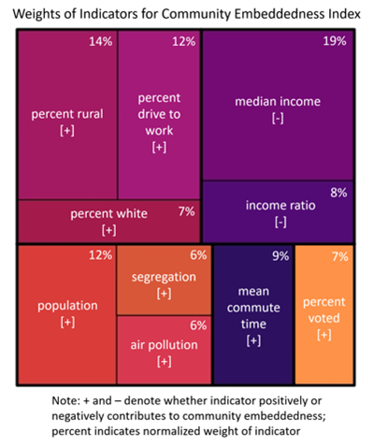
The single largest contributor is median income, which negatively contributes to the index, (i.e., counties with higher incomes tend to have lower levels of community embeddedness). Other factors that contribute to embeddedness are illustrative of the community’s setting (rural indicators: rurality, driving to work; urban indicators: air pollution, segregation). Finally, there are factors that describe the people within a community, which may influence their ability and willingness to leave (income, population, percent white, commute time, voter turnout).

Using the Index

To look at how the presence of an Army post might be linked to community embeddedness, we focused in on two specific counties containing installations: Caroline County, Virginia (Fort A.P. Hill) and Comanche County, Oklahoma (Fort Sill). These locations were selected because the Army posts have similar training missions and their home counties, as well as all surrounding counties, share similar rural properties. Comparisons can be drawn between the counties that possess Army posts and those that do not.

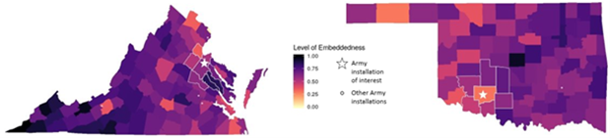
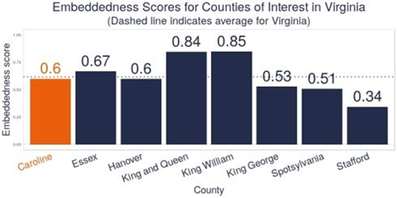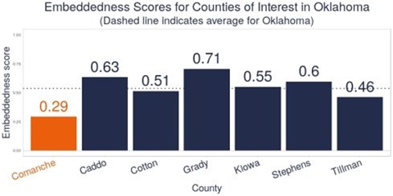

Discussion

Comanche County, Oklahoma has lower community embeddedness than its neighboring counties. Caroline County, Virginia has similar embeddedness from its surrounding counties. Our research demonstrates the feasibility of constructing a community embeddedness index and is a first step to measuring how the presence of an Army post might relate to embeddedness. Future analyses should also explore other reflective measures of community embeddedness beyond migration patterns, as the value of an index is typically tied to its ability to predict multiple outcomes (e.g., number of public-private community partnerships, election turnout).

Examining community embeddedness in each state also provides interesting results. For example, Southwest Virginia has high embeddedness indexes, which is not surprising given how community embeddedness is defined here. This part of Virginia is in the heart of Appalachia and the community embeddedness index reflect the lower incomes in this part of the state. [So we talk about the interesting results, and again I feel there was some scope here to address those interesting results and how understanding this would lead to future action apart from next-generation analyses.]

